Project Design Phase-II
Technology Stack (Architecture & Stack)
Date | 12 July 2026
Team ID | SB_2026_NutriAssist_01
Project Name | NutriAssist — Personalized Nutrition Assistant
Maximum Marks | 4 Marks

Technical Architecture
NutriAssist follows a 3-tier MERN architecture: a React single-page application communicates over a REST API with a Node.js/Express backend, which reads from and writes to a MongoDB database through Mongoose. Requests to protected routes carry a JWT bearer token that authMiddleware verifies before handing control to the relevant controller.
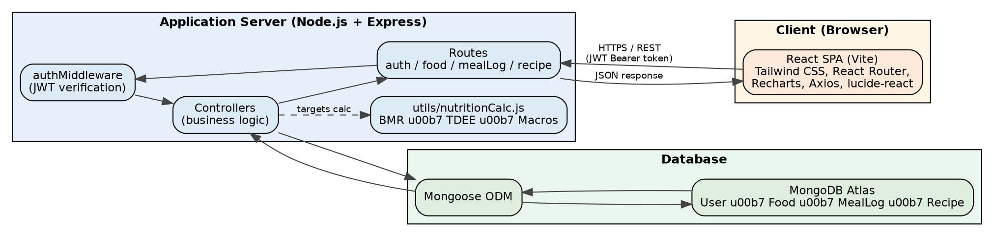
Fig 1: NutriAssist technical architecture — React client, Express API, MongoDB

Table-1: Components & Technologies
S.No | Component | Description | Technology
1 | User Interface | Web UI — how the user interacts with the application (registration, dashboard, meal logging, recipes). | React (Vite), Tailwind CSS, React Router, Axios, Recharts, lucide-react
2 | Application Logic-1 | Authentication and health-profile management. | Node.js, Express, authController, authMiddleware (JWT verification), bcrypt (password hashing)
3 | Application Logic-2 | Meal logging, food search, and daily/weekly nutrient tracking. | Node.js, Express, foodController, mealLogController
4 | Application Logic-3 | BMR/TDEE/macro-target calculation and recipe & grocery-list generation. | Node.js, Express, utils/nutritionCalc.js (Mifflin-St Jeor formula), recipeController
5 | Database | Stores users, reference foods, meal logs, and recipes. | MongoDB with Mongoose ODM (User, Food, MealLog, Recipe collections)
6 | Cloud Database | Managed database service used for the deployed environment. | MongoDB Atlas (cloud, free tier)
7 | File Storage | Static assets (hero graphic, icons) bundled with the client. | Local filesystem (client/src/assets); no user-uploaded file storage in the current build
8 | External API-1 | Not yet integrated — recipe and food data currently come from curated/seeded demo data rather than a live source. | Planned: a live nutrition/recipe data API (see Future Enhancements)
9 | External API-2 | Not yet integrated — no third-party lookups are used in the current build. | None currently used
10 | Machine Learning Model | Not used — recommendations are computed with a deterministic formula, not a trained model. | Not applicable (Mifflin-St Jeor BMR formula, not ML-based)
11 | Infrastructure (Server / Cloud) | Local Server Configuration: backend (npm run dev) on http://localhost:5000 and frontend on http://localhost:5173, run locally during development. Cloud Server Configuration: planned — frontend on Vercel, backend on Render, database on MongoDB Atlas, with CI/CD (see Future Enhancements). | Local (current), Vercel + Render + MongoDB Atlas (planned)

Table-2: Application Characteristics
S.No | Characteristics | Description | Technology
1 | Open-Source Frameworks | Frameworks and libraries used to build the client and server. | React, React Router, Tailwind CSS, Axios, Recharts, lucide-react, Node.js, Express, Mongoose, jsonwebtoken, bcrypt
2 | Security Implementations | Access control and data-protection measures implemented. | bcrypt password hashing (salted, 10 rounds); JWT-based authentication verified by authMiddleware on every protected route; requests with a missing, malformed, or expired token are rejected with 401 before reaching the controller
3 | Scalable Architecture | Justification for the scalability of the architecture. | 3-tier architecture (React client / Express API / MongoDB); stateless JWT authentication (no server-side sessions) allows the API layer to scale horizontally behind a load balancer
4 | Availability | Justification for the availability of the application. | Currently a single-instance local deployment for development; planned production deployment (Vercel + Render + MongoDB Atlas) would add managed uptime and Atlas replica sets for database availability
5 | Performance | Design considerations for application performance. | A single shared Axios instance attaches auth headers once per request; the Food collection is indexed for text search; the weekly dashboard chart uses a single zero-filled aggregation query on the server instead of multiple round trips

References
https://c4model.com/
https://www.mongodb.com/docs/manual/
https://expressjs.com/
https://react.dev/
https://jwt.io/introduction

